

**DATA STRUCTURES & ALGORITHMS**

**(IT111N)**

**GROUP ASSIGNMENT**

**SESSION: JANUARY 2021**

# **Student Particulars**

|  |  |  |
| --- | --- | --- |
| Name | : | 1.Alex Cheow Eng Keat  2.Chan Kar Fong  3.Loh Li Xin |
| IC Number | : | 1.020222-07-0601  2.000209-08-0081  3. 011220-07-0523 |
| Student Number | : | 1.SCPG2000043  2.SCPG1900547  3. SCPG1900577 |
| Course Programme | : | Diploma in Information Technology |
| Intake | : | May & Aug 2019, Jan, Mar & Apr 2020 |
| Subject Title | : | Data Structures & Algorithms |
| Subject Code | : | IT111N |
| Assignment Title | : | Group Assignment |
| Name of Lecturer | : | Intan Najua binti Kamal Nasir |
| Due Date | : | 5th April 2021, Monday, Before 11 pm (Softcopy)  5th April 2021, Monday, Before 6 pm (Hardcopy) |
| College | : | Segi College, Penang |

**Declaration by student(s):**

We, Alex Cheow Eng Keat,Chan Kar Fong and Loh Li Xin hereby declare that the attached assignment is our own work and understand that if we are suspected of plagiarism or another form of cheating; our work will be referred to the lecturer who may, as a result recommend to the Examinations Board that our enrolment in the programme be discontinued.

**Alex Chan Loh**

**8 April 2021**

**_________________ __________________________________________**

**Date Signature of Students**

# **Assignment Allocation of Marks**

|  |  |  |  |
| --- | --- | --- | --- |
| **No.** | **Description of criteria** | **Weightings** | **Marks Allotted by Lecturer** |
|  | Question 1 | 50% |  |
|  | Question 2 | 50% |  |
|  | **Total Mark** | 100% |  |
|  | **Total Mark in 20%** | 20% |  |

**Comment(s):** ________________________________________________________________________________________________________________________________________________________________________________________________________________________________________________________________________________________________________________________________________________________________________________________________________________

_________________________________

Lecturer: Intan Najua binti Kamal Nasir

Date:

# **Learning Outcome Assessed**

|  |  |
| --- | --- |
| CLO2 | Apply the different data structures methodologies in their programming as part of the problem-solving process. |
| CLO3 | Write program to demonstrate data structures application |

# **Assignment Instruction**

The purpose of this assignment is to examine your ability using knowledge on writing program. Students are required to complete the assignment in a group of **MAXIMUM 3 MEMBERS**.

Each member will take responsibility for ALL requirements which should give the same load of work as other members.

# **Assignment Title**

You are required to complete the **TWO (2)** questions below.

**QUESTION 1 (50%)**

You are about to develop a simple Pokémon hunter journal application to keep track of the Pokémon hunter names, Pokémon’s stored, and Pokémon stops visited. Your program should be able to handle an unlimited entry by using array data structure.

**You may use different classes/structure to represent the record details:**

1. Pokémon (store Pokémon Name, Pokémon Type [Normal, Ground, Fire, Fighting, Water, Grass, Rock, Electric, Bug, Physic Poison, Dragon]), CP total, Data Caught, height and weight)
2. Pokémon Hunter (First Name, last Name, Player Level, Gender and Team Type [None, Mystic, or Instinct])
3. Visited Pokémon stops (Date, Time and Items Received)
4. Raid (Date, Time and Venue)

**The program should perform the following operations:**

* Load the data into the Pokémon journal from a memory/disk.
* Search for a Pokémon hunter by last name or team type.
* Print or display the list of Pokémon’s caught by a Pokémon hunter based on either by CP total, Pokémon type or recently caught Pokémon.
* Print or display the list of Pokémon hunters whose at which player level, team type or gender.
* Add a new entry of Pokémon’s caught, Pokémon hunter, raid or Pokémon stops visited from the journals.
* Delete existing entry of Pokémon’s caught, Pokémon hunter, raid or Pokémon stops visited from the journal.
* Allow the user to save the data of Pokémon’s caught, raid, Pokémon hunter or Pokémon stops visited in the journal.

**QUESTION 2 (50%)**

You are about to write a **STACK (LIFO) or QUEUE (FIFO)** program using **linked list**. You are required to come out with a scenario that using stack or queue and linked list. It could be a simple game or any applications.

**The program should include the following operations:**

1. You are required to include **PUSH** and **POP** or **APPEND** and **SERVE** operations.
2. Provide at least **TWO (2)** test cases with sample screenshots.

**Screenshot 1**

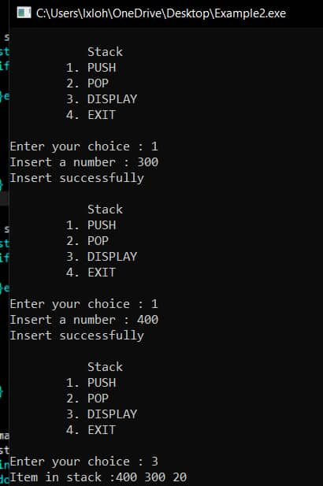

**Screenshot 2**

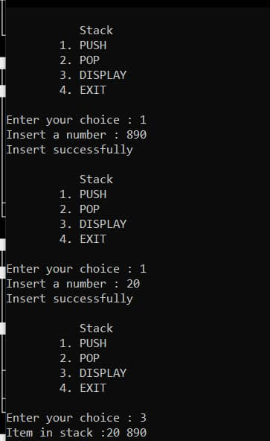

# **Assignment Submission**

1. Create **ONE (1)** project for each question. Name each question as Question 1 and Question 2.
2. Create a README.txt and put all group member details in the file.
3. Zip the two projects and text file together.

Please submit your HARDCOPY of group assignment attached with the assignment cover page (page 1 to page 3) before or on **5th April 2021, Monday, 6 pm**. And, upload the SOFTCOPY onto the Blackboard coursework submission link before or on **5th April 2021, 11 pm**. All coursework should be submitted on the scheduled dateline. Extension is not normally granted, but in exceptional case, limited extension may be granted.

In term of late submission, a **10% deduction per day** of total marks, excluding weekends and public holiday(s). Late submission between **5 to 10 days will deduct 50 %** of the total marks. After 10 days, **submission is not accepted** and it **will result in an automatic 0%** for the assignment.